**GETTING STARTED**

* Each organization should only have one account, the user will be the primary contact for the entire grants process within the organization
* An email can only be linked to one user account
* The email address used to create the account will become the users log in
* If you are unsure whether your organization has an account, please email [sigourney@cvcfoundation.org](mailto:sigourney@cvcfoundation.org) prior to creating a new user account
* An organizations account will be used every year to apply and will contain all historical grant applications made in this system

**CREATE A NEW ACCOUNT:**

* Creating a new account is a multi-step process;
  + with the first section collecting **Organization Information**;
  + the second section collecting **User Information**;
  + and sections three and four collecting **President** information.

* After Organization Information has been entered click on the “**Next**” button.
* The next section is the “**User** **Information**” section, or YOUR information.
  + If your address is the same as your organizations, you may use the “**Copy Address from Organization**” button to automatically pull the address information from the organization address fields into the address fields in this section.
  + It is very important to note that the email address entered in the **Email/Username** field becomes the Applicant’s **Username** in the system.
* Once the fields on the “**User** **Information**” section are completed, click on the “**Next**” button.
  + Please note that should you need to navigate to previous section in the registration process, you must use the “**Previous**” button at the bottom of each section for the information entered in registration fields to remain intact. If you attempt to navigate to the previous section by using their browser's “back” button you will lose all registration information entered.
* In the next section you indicate if you are the Organization’s President or similar position.
  + If you are the President, select “**Yes**.” You are taken to a section of optional fields that includes only the fields that were not required in the **“User Information”** section.
  + If you are not the executive officer, select “**No**,” and complete the required President fields.
* Once the President’s information is entered, click on the “Next**”** button to create a password.
* Password requirements are listed at the top of the section, so the applicant can create their password accordingly.
* Once the password is created, the applicant clicks the “**Create Account”** button.

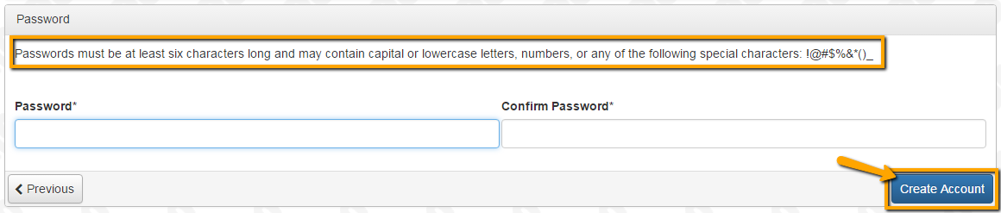

**EMAIL CONFIRMATION:**

Upon clicking Create Account you will be taken to the Email Confirmation page, so you can confirm that you are receiving emails from the system. Follow the onscreen instructions and click the “Continue” button to finish the registration process. Now you have an account in this system, and remember, this is an account that you will use for both present and future applications.

**APPLYING FOR GRANTS**

Click **Apply** to reach the Apply Page which lists the available grant opportunities and details about each. This page will show you any currently open opportunities that you can apply for, as well as any relevant deadlines and other applicable information related to them.

* You can preview the application without having to save any work by clicking on the “Preview” button.
* To start a request, click on the blue **“Apply”** button under the opportunity you’d like to apply to.
  + Clicking Apply will take you into a form to complete and submit.
  + If the Apply button is not available, then the Foundation is not accepting applications at this time

Once in the form, note that your contact and organization information automatically populates at the top of the form.

* You may update your contact information and view your email history.
  + The edit icon is next to the Organization Information.
* If you’d like a PDF copy of the application, you can click the Question List button.
* Once you’ve completed the form, you may click the Application Packet button to download a copy of the questions and your responses.
* Please note that if the form has a specific deadline it will be listed at the top of the form. No late applications will be accepted

Work your way through the form responding to the fields.

* Note that any fields with an asterisk are required fields and must be completed prior to submitting an application.
* As you complete the form, the system will auto-save every 100 characters typed or every time you click out of a field.
* You may collapse question groups as you go, once you’ve finished all of the questions in that group, as an indicator to yourself that you’ve completed that section and reduce scrolling.
* Some fields have character limits.
  + Responses that are longer than the set limit will be saved, ***but*** an error message will appear informing the applicant the the limit has been exceeded.
    - You will not be allowed to submit the form until the length of the response has been decreased in accordance with the limit.
* File **upload fields** will only accept one file, per field.
  + Upload fields have size limits.
    - If you attempt to upload a file that is larger than the set MiB limit, you will receive an error message informing the applicant that the file is too large and the file **will not** be saved.
  + Upload fields may also have File Type restrictions.
    - If you attempt to upload a file type in an unaccepted file type acceptable file type you will receive a warning that the file type is not acceptable and you will not be able to upload the file.
  + Once a file has been uploaded, it may be **deleted** by clicking the **red X** next to the file name and a new file can be uploaded.
* Even though the system is auto-saving there is still a “**Save”** button at the bottom of the form.
  + When you click save you are taken to a confirmation page so you know the save was successful.
    - If you click “**Continue**” you will be taken back into the form so you can continue working.
    - If you save and exit the system, you will access the **draft of the form** from your **Dashboard** the next time you log in.
      * Pick back up where you left off by clicking “**Edit**” link to the right of the request.

* You may abandon the request if it is the first form to be submitted for this request.
  + Once the Application, has been submitted you must contact an administrator to withdraw the request from consideration.
  + After selecting Abandon Requests, you must type in Abandon Request and select OK
  + The request will then be visible in the Historical Requests tab just as it would if an administrator had abandoned the request.

When all of the fields are complete, submit the application.

* If any required fields were not completed, or a response to a text question type is longer than the set limit, the system will not allow the form to be submitted.
  + An error message appears listing the fields that need to be completed or edited.
  + These fields are outlined in red so they are easy to identify as the applicant scrolls through the form.
* When a form is submitted successfully, the applicant will be taken to a confirmation page.
  + When the you click “**Continue”** you are taken to your dashboard where you can VIEW your submitted request.
  + Note, that once an application has been submitted you can no longer edit it.

**APPLICANT DASHBOARD**

Your dashboard houses current and historical requests.

The active request tab houses all current requests. These are the requests still requiring action, awaiting a decision and/or requests that have not yet been marked closed by the site administrator.

* You may continue working on saved forms by clicking the start button or the arrow option next to the form.
* You may view forms that have been submitted but note that once submitted you can not edit them.

Every submitted application will receive a response by email, regardless of the outcome.

Approved requests have a ribbon icon to indicate a decision has been made.

If your request is approved you will be assigned Follow Up Forms to be completed and submitted through the system.

* Follow ups are completed and submitted just like any other form.
* If you’ve been assigned multiple follow up forms, you must complete them sequentially by due date.
* Follow ups that are past due will be marked as such.
  + If the past due message is reflected in orange, you may still submit the form.
  + If the past due message is reflected in red, you no longer have the option to submit the form.

Denied requests, abandoned and requests marked closed by the site administrator are housed in the Historical tab.

If you wish to edit your account information or change your password, click your name in the type right. This will expand a drop-down menu. If you click Edit my profile, you will be able to update your user information or change your password. Be sure to click save in the bottom right once you’ve finished.

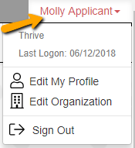

Please note, that you will be automatically logged out of the system after 90 minutes of inactivity (you

will receive a warning message at 80 minutes of the pending “time out”).